**Classification results**

* Support vector machine (SVM) is used for classification.
* Video data collected from NICU at MSRH are annotated and labeled into three classes i.e., Moderate, None and Severe pain based on the Wong bakers pain scale.

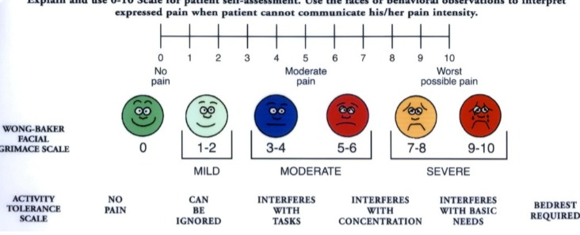

* Labeled data is divided into training and testing data.
* Moderate, none and severe are the three classes.



* Some of the key parameters in SVM are:

→Gamma : defines how far the influence of single training examples reaches values leads to biased results.

→ C : Controls the cost of miscalculations

Small C — makes the cost of misclassification LOW

Large C — makes the cost of misclassification HIGH

→ Kernel : SVM algorithms use a set of mathematical functions that are defined as the kernel.

* RBF(Radial Basis Function), Polynomial Kernel are deployed.



Below are results of classifier

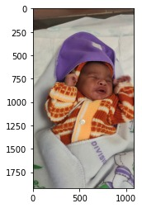

**moderate = 95.3253408163106%**

**None = 2.420899909551253%**

**severe = 2.2537592741381443%**

**The predicted image is : moderate**

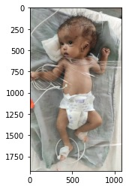

**moderate = 25.095100341583905%**

**None = 60.30653489330289%**

**severe = 14.598364765113189%**

**The predicted image is : None**

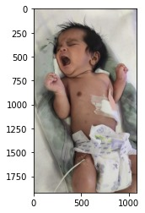

**moderate = 8.648209596205698%**

**None = 3.2216067411114846%**

**severe = 88.13018366268282%**

**The predicted image is : severe**

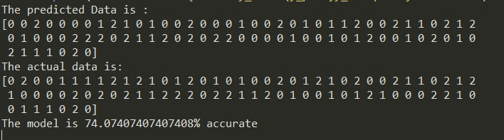

* Model is also tested for completely unknown data

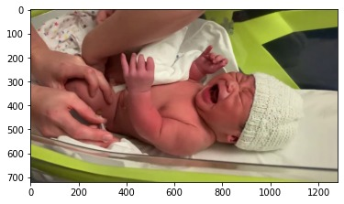

**moderate = 40.38214589165237%**

**None = 20.109537893228474%**

**severe = 39.50831621511915%**

**The predicted image is : moderate**

**recall score for all three classes (0.7773809523809524, 0.7374162381175005, 0.7483076755104269)**

* Algorithm gives **73%** accuracy.

**Drawbacks**

* SVM algorithm is not suitable for large data sets.
* If the data is irregular, accuracy drops significantly.
* If the number of features for each data point exceeds the number of training data samples, the SVM will underperform.